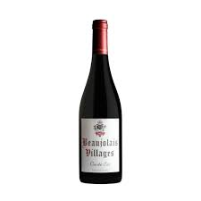

Description:
Julienas Beaujolais-Villages Cuvée Six is a vibrant Gamay from the rolling hills of Beaujolais, made with fruit sourced from six neighbouring villages just outside the cru boundaries. Fermented semi-carbonically and aged in stainless steel, it offers the bright fruit and lift typical of the region, with added depth from careful blending.
Tasting notes:
Aromas of ripe red cherry, raspberry, and a hint of peony. The palate is juicy and light on its feet, with soft tannins, fresh acidity, and a smooth, fruit-forward finish.
Allergens: Contains sulphites.
Dish Pairing:
• Charcuterie and pâté
• Roast chicken with herbs
• Grilled halloumi
• Tomato and olive tart
• Mild washed-rind cheeses
Talking Point:
Cuvée Six takes its name from the six villages that contribute to the blend, offering a snapshot of Beaujolais terroir beyond the crus. It’s made in the spirit of classic bistrot wine—fresh, lively, and easy to love, with real attention to quality.

