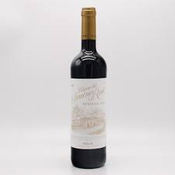

Description:
Palacio del Camino Real Reserva is a classic Rioja red from the prestigious San Vicente de la Sonsierra in Rioja Alta. This wine is a blend of Tempranillo, Garnacha, and a touch of Viura, aged for 20 months in a combination of French and American oak, followed by further bottle ageing to bring depth and harmony.
Tasting Notes:
Deep garnet in colour with aromas of ripe blackberries, plums, vanilla, and a touch of dark chocolate. The palate is smooth and structured, showing layered dark fruit, fine tannins, and gentle spice, with a long, balanced finish.
Allergens: Contains sulphites.
Dish Pairing:
• Roast lamb or pork
• Charcuterie and cured meats
• Mushroom risotto
• Grilled steak with paprika
• Aged Manchego
Talking Point:
Named after the “Royal Way” once used by Spanish monarchs, this Reserva pays tribute to Rioja’s long winemaking history. The extended oak ageing gives the wine structure and savoury depth while retaining the elegance and vibrancy typical of Rioja Alta fruit.

