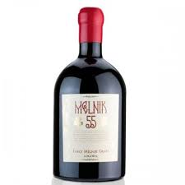

Description:
Melnik 55 in Magnum is a bold red wine made from the Melnik grape variety, indigenous to southwestern Bulgaria. Grown in the Struma River Valley, this wine is produced in larger magnum format to encourage slower ageing and greater complexity. Melnik 55 is a cross between Broadleaf Melnik and the French variety Valdiguié, known for producing vibrant, structured wines with both spice and fruit.
Tasting notes:
Aromas of blackberry, cherry, and black pepper with subtle oak undertones. The palate offers dark fruit, cocoa, and earthy notes, with well-integrated tannins and a touch of spice on the finish.
Allergens: Contains sulphites.
Dish Pairing: Roast lamb, grilled sausages, moussaka, mature cheeses, mushroom risotto
Talking Point:
Melnik is one of the oldest winemaking regions in Europe—legend has it that Winston Churchill was a fan of wines made from this grape, ordering barrels each year for his personal cellar.

