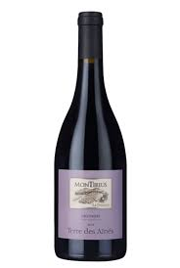

Description:
Monterius Gigondas Terre des Aînés is a robust red wine from the southern Rhône Valley, produced predominantly from old-vine Grenache with Syrah and Mourvèdre. The wine is grown on the rugged slopes of the Dentelles de Montmirail, where stony soils and strong mistral winds contribute to its structure and intensity. This is a powerful yet well-balanced example of the appellation’s bold, age-worthy reds.
Tasting notes:
Deep ruby in colour with aromas of blackberry, dried herbs, black pepper, and liquorice. The palate is full-bodied and layered, showing ripe dark fruit, garrigue, and savoury spice, framed by firm tannins and a lingering, earthy finish.
Allergens: Contains sulphites.
Dish Pairing:
- Roast leg of lamb
- Wild boar stew
- Aged hard cheeses
- Grilled aubergine
- Duck breast with blackcurrant sauce
Talking Point:
“Terre des Aînés” translates to “Land of the Elders”, a tribute to the older generations who shaped the vineyards and practices of Gigondas. The wine reflects both their legacy and the strength of old vines rooted in challenging, arid terrain—bringing depth and history to every glass.

